Marketplace
Recreation, Leisure & Learning
Program Guide
Spring 2019
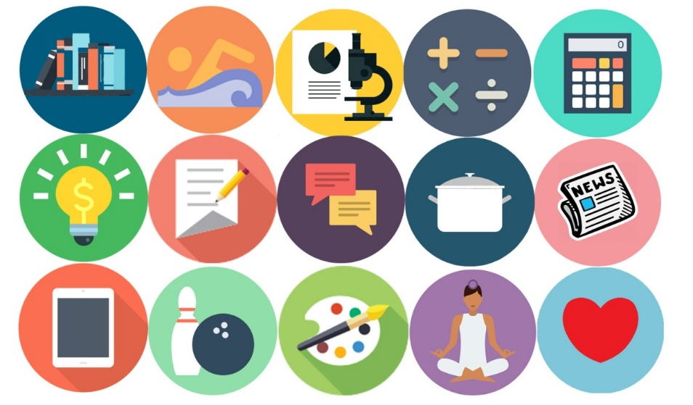

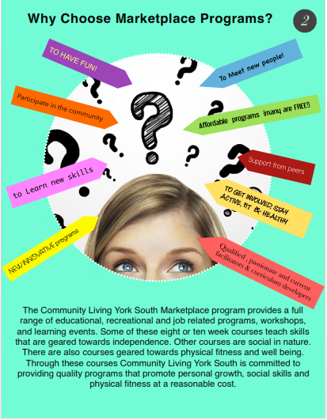
 | MARKHAM MARKETPLACE SPRING 2019
 | Monday |  | Tuesday |  |  | Wednesday |  | Thursday |  | Friday
Program | Everyday Healthy Cooking | Fitness at YMCA | Literacy & Book Club | Knitting Group ( bi –weekly) | Computer Essentials( bi –weekly | Creative Problem Solving | Fitness and Swimming at YMCA | Dance | Chef’s Corner |  | Social Club
Location | Armadale CC | 101 YMCA Blvd., Unionville | Aaniin Community  Centre  ( bubble room) | CLYS Markham Office | Markham Village Library | Stiver Mills Hall | 101 YMCA Blvd.,  Unionville | Milliken Mills Community Centre | Ballantrae Community Centre |  | CLYS Markham Office (1st program)
Time | 10:00-12:00 | 1:00-2:30 | 10:00-12:00 | 1:00-3:00 | 1:00-3:00 | 9:30-11:45 | 1:00-2:30 | 9:30-11:30 | 5:00-7:00 |  | 6:00-8:00
Dates | March 25 April 1, 8, 15, 22, 29 May 6, 13, 20, 27 | March 25 April 1, 8, 15, 22, 29 May 6, 13, 20, 27 | March 26 April 2, 9, 16, 23, 30  May 7, 14, 21, 28 | April 2 16, 30  May 14, 28 | April 9, 23 May 7, 21 | March 27 April 3, 10, 17, 24 May 1, 8, 15, 22, 29 June 5 | March 27 April 3, 10, 17, 24  May 1, 8, 15, 22, 29  June 5 | March 28 April 4, 11, 18, 25  May 2, 9, 16, 23, 30 | March 28 April 4, 11, 18, 25  May 2, 9, 16, 23, 30 |  | March 29  April 12, 26  May 10, 24
Cost | $ 122.56 | $30.00 | $ 75.00 | $25.00 | FREE | $ 97.41 | $30.00 | $112.96 | $ 125..00 |  | Based upon activities
Register | Town of Markham  Code: 34182 | Marketplace  marketplace@communitylivingyorksouth.ca | Marketplace  marketplace@communitylivingyorksouth.ca | Marketplace  marketplace@communitylivingyorksouth.ca | Marketplace  marketplace@communitylivingyorksouth.ca | Town of Markham  Code:  335808 | Marketplace  marketplace@communitylivingyorksouth.ca | Town of Markham  Code:  335807 | Town of Whitchurch-Stouffville  Code:  7010 |  | Marketplace  marketplace@communitylivingyorksouth.ca

 | RICHMONDHILL MARKETPLACE SPRING 2019
 | Tuesday |  | Wednesday |  | Thursday | Friday |  |  | Saturday
Program | Arm Chair Travel | Artistic drawing | Social Group | Cooking | Drama |  | Cooking | Lunch and Learn |  | G1 Preparation Course
Location | Richmond Hill Library  1 Atkinson St, Richmond Hill, ON L4C 0H5 | Richmond Hill Library  1 Atkinson St, Richmond Hill, ON L4C 0H5 | Richmond Hill Library  1 Atkinson St, Richmond Hill, ON L4C 0H5 | Longos  10860 Yonge St  Richmond Hill  L4C 3E4 | Welcome Centre South Hill Shopping Centre  9325 Yonge St  Richmond Hill  L4C 0A8 |  | Longos  10860 Yonge St  Richmond Hill  L4C 3E4 | The Hub –Entrance facing Yonge Street  10415 Yonge St. Richmond Hill L4C 0Z3 |  | The Hub –Entrance facing Yonge Street  10415 Yonge St. Richmond Hill L4C 0Z3
Time | 10:30 am – 12:00 pm | 10:30 am – 12:00 pm | 10:00 am -12:00 pm | 6:00 pm -8:00 pm | 6:00 pm -8:00 pm |  | 6:00 pm -8:00 pm | 11:00 am -1:00 pm |  | 10:00 am- 12:00 pm
Dates | April 2, 9, 16, 23,  May 7, 14 | May 21, 28  June 4, 11, 18, 25 | April 3, 10, 17, 24  May 8, 15, 22, 29  June 5, 12, 19 | May 1, 8, 15, 22, 25  June 5, 12, 19, 26 | May 2, 9, 16, 23, 30  June 6, 13, 20, 27 |  | April 19, 26  May 3, 10, 17, 24, 31  June 7, 14, 21 | April 19, 26  May 3, 10, 17, 24, 31  June 7, 14, 21 |  | Mar 23, 30  April 6, 13, 20, 27  May 4, 11, 18, 25
Cost | Free | Free | Free | $10.00 per class | $90.00 |  | $10.00 per class | Free |  | $90.00
Register | Marketplace  marketplace@communitylivingyorksouth.ca | Marketplace  marketplace@communitylivingyorksouth.ca | Marketplace  marketplace@communitylivingyorksouth.ca | Marketplace  marketplace@communitylivingyorksouth.ca | Marketplace  marketplace@communitylivingyorksouth.ca |  | Marketplace  marketplace@communitylivingyorksouth.ca | Marketplace  marketplace@communitylivingyorksouth.ca |  | Marketplace  marketplace@communitylivingyorksouth.ca
Markham
Monday
Everyday Healthy Cooking
Description: In the everyday cooking classes, we open up to the world of cuisine and get in-depth about ingredients, nutrition, equipment selection, and culinary techniques.
Location: Armadale Community Centre (2401 Denison St.)
Time: 10:00 am-12:00 noon
Dates: March 25 April 1, 8, 15, 22, 29 May 6, 13, 20, 27
Cost: $122.56
Register with Town of Markham
Course Code: 34182

Fitness at YMCA
Description: YMCA fitness provides swimming, group fitness classes, free weights, and recreational sports.
Location: 101 YMCA Blvd, Unionville
Time: 1:00pm-2:30pm
Dates: March 25 April 1, 8, 15, 22, 29 May 6, 13, 20, 27
Cost: $30.00
Register with Marketplace Program
marketplace@communitylivingyorksouth.ca or (905) 294-4971 ext. 450

Tuesday
Literacy/Book Club
Description: Develop basic literacy skills that will enable you to function more effectively in your personal and community life.
Location: Aaniin Library (5665 14th Ave.)
Time: 10:00am-12:00 noon
Dates: March 26 April 2, 9, 16, 23, 30 May 7, 14, 21, 28
Cost: $75.00 (books and materials not included)
Register with Marketplace Program
marketplace@communitylivingyorksouth.ca or (905) 294-4971 ext. 450

Knitting Group (bi-weekly)
Description: Learn the basic techniques of knitting stitches.
Location: CLYS Markham Office (5694 Hwy 7, Unit #13)
Time: 1:00pm-3:00pm
Dates: April 2, 16, 30 May 14, 28
Cost: $25.00
Register with Marketplace Program
marketplace@communitylivingyorksouth.ca or (905) 294-4971 ext. 450

Computer Essentials (bi-weekly)
Description: Designed to teach various topics pertaining to computers, the Internet, and its impact on our health.
Location: Markham Village Library (6031 Hwy 7)
Time: 1:00pm-3:00pm
Dates: April 9, 23 May 7, 21
Cost: FREE
Register with Marketplace Program
marketplace@communitylivingyorksouth.ca or (905) 294-4971 ext. 450

Wednesday
Creative Problem Solving
Description: This course will explore different methods of problem solving skills and how to apply the methods with friends, acquaintances or strangers in order promote healthy relationships.
Location: Stiver Mills Hall (Unionville)
Time: 9:30 am-12:00 noon
Dates: March 27 April 3, 10, 17, 24 May 1, 8, 15, 22, 29 June 5
Cost: $ 127. 36
Register with the Town of Markham
Course code: 335808

Fitness at YMCA
Description: YMCA provides swimming, group fitness classes, free weights, and recreational sports.
Location: 101 YMCA Blvd, Unionville
Time: 1:00pm-3:00pm
Dates: March 27 April 3, 10, 17, 24 May 1, 8, 15, 22, 29 June 5
Cost: $30.00
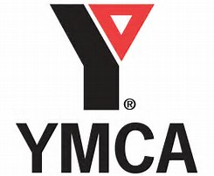
Register with Marketplace Program
marketplace@communitylivingyorksouth.ca or (905) 294-4971 ext. 450

Thursday
Dance
Description: Learn the basic techniques to dance.
Location: Milliken Mills Community Centre
Time: 9:30am-11:30 am
Dates: March 28 April 4, 11, 18, 25 May 2, 9, 16, 23, 30
Cost: $112.96
Register with the Town of Markham
Course code: 335807

Chef’s Corner Cooking
Description: Skills taught include independent cooking, kitchen safety, proper use of equipment, food presentation, dinner etiquette and healthy lifestyles.
Location: Ballantrae Community Centre (5592 Aurora Rd.)
Time: 5:00pm-7:00pm
Dates: March 28 April 4, 11, 18, 25, May 2, 9, 16, 23, 30
Cost: $112.50
Resister with Town of Whitchurch-Stouffville
Course Code: 4960

Friday
Friday Night Social Club
Description: Building healthy relationships in group and community settings.
Location: CLYS Markham Office for first gathering (5694 Hwy 7, Unit #13)
Time: 6:00pm-8:00pm
Dates: March 29 April 12, 26 May 10, 24
Cost: based upon activities
Register with Marketplace Program
marketplace@communitylivingyorksouth.ca or (905) 294-4971 ext. 450

Richmond Hill
Tuesday
Arm Chair Travel
Description: Takes people to faraway places without leaving home.
It provides a sensory experience and the opportunity to learn about exotic lands.
Location: Richmond Hill Library (1 Atkinson st)
Time: 10:30 am – 12:00 pm
Dates: April 2, 9, 16, 23 May 7, 14
Cost: Free
Register with Marketplace Program
marketplace@communitylivingyorksouth.ca or (905) 294-4971 ext. 450

Artistic Drawing
Description: Learn drawing techniques such as shading, shapes, sketching and more!
Location: Richmond Hill Library (1 Atkinson st)
Time: 10:30 am – 12:00 pm
Dates: May 21, 28 June 4, 11, 18, 25
Cost: Free
Register with Marketplace Program
marketplace@communitylivingyorksouth.ca or (905) 294-4971 ext. 450

Wednesday
Social Group
Description: The social group will provide you with the opportunity to gather weekly with old and new friends in a relaxed and comfortable setting.
Location: Richmond Hill Library (1 Atkinson st)
Time: 10:00 am-12:00 pm
Dates: April 3, 10, 17, 24 May 8, 15, 22, 29 June 5, 12, 19
Cost: Free
Register with Marketplace Program
marketplace@communitylivingyorksouth.ca or (905) 294-4971 ext. 450

Cooking at Longos
Description: Learn to prepare basic meals and take home recipes allowing the opportunity to continue making the dishes they learn to prepare.
Location: Longo’s (10860 Yonge St.)
Time: 6:00pm – 8:00pm
Dates: May 1, 8, 15, 22, 29 June 5, 12, 19, 26
Cost: $10.00 Per Class
Register with Marketplace Program
marketplace@communitylivingyorksouth.ca or (905) 294-4971 ext. 450

Thursday
Drama
Description: Let your voice be heard. Let your story be told
Location: Welcome Centre South Hill Shopping (9325 Yonge St)
Time: 6:00 pm – 8:00 pm
Dates: May 2, 9, 16, 23, 30 June 6, 13, 20, 27
Cost: $90.00
Register with Marketplace Program
marketplace@communitylivingyorksouth.ca or (905) 294-4971 ext. 450

Friday
Cooking at Longos
Description: Learn to prepare basic meals and take home recipes allowing the opportunity to continue making the dishes they learn to prepare.
Location: Longo’s (10860 Yonge St.)
Time: 6:00pm – 8:00pm
Dates: April 19, 26 May 3, 10, 17, 24, 31June 7, 14, 21
Cost: $10.00 Per Class
Register with Marketplace Program
Lunch And Learn
Description: Learn about different health related topics. This includes themes such as Canadas new Food Guide, proper hygiene, Diabetes, Heart Disease, how to deal with stress and much more. A complimentary snack will be provided and a fun physical activity will take place during the second half of the course.
Location: The Richmond Hill Hub (10415 Yonge St.)
Time: 11:00 am – 1:00 pm
Dates: April 19, 26 May 3, 10, 17, 24, 31 June 7, 14, 21
Cost: Free
Register with Marketplace Program
marketplace@communitylivingyorksouth.ca or (905) 294-4971 ext. 450

Saturday
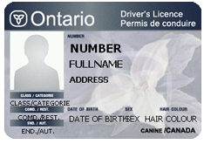
G1 Preperation
Description: Want to get your G1? Here’s your opportunities to learn to road rules.
Location: The Richmond Hill Hub (10415 Yonge St.)
Time: 10:00 am – 12:00 pm
Dates: April 19, 26 May 3, 10, 17, 24, 31 June 7, 14, 21
Cost: Free
Register with Marketplace Program
marketplace@communitylivingyorksouth.ca or (905) 294-4971 ext. 450

Participant Name: ___________________________________ Male: ____ Female: ____
Birthday: ________________________________________________ Age: __________
Full Address: ____________________________________________________________
Telephone #: _________________________ Alternate #: _______________________
Email: ________________________________________________________________
Emergency Contact: ____________________ Emergency Contact #: _______________
Pertinent Medical/Health Info: ______________________________________________
_______________________________________________________________________
Allergies: Yes: ___ No: ___ Describe: ________________________________________
Assisted Devices: ______________________ Mobility Aids: _______________________

Independence Level/Supports to Participate in Marketplace Programs
I require staff support to participate (I will bring my support worker): ______________
I am independent: ________ Partial Supports Required: ________ Describe: ________ _______________________________________________________________________
Read Yes No Write Yes No Large Print Required Yes No Visuals Required Yes No

Program Name: | Dates: | Time: | Fee:

Signature: __________________________________________ Date: ______________
Register with (905) 294-4971 ext. 450 or marketplace@communitylivingyorksouth.ca

